DAT602 Database Application Development
Assignment 1 - Project Proposal & Milestone Two Report

Moratu Hewage Tharuki Siyara

Contents
01.Game Description 4
02.Design and Analysis 5
2.1 Player Login and Account Lockout 5
2.2 Player Registration 5
2.3 Player Deletes Their Own Account 5
2.4 Laying Out Tiles on the Game Board 5
2.5 Placing an Item on a Tile 6
2.6 Live Player Movement 6
2.7 Game Scoring 6
2.8 Acquiring and Using Inventory 6
2.9 Patrol Bot and Glitch Movement 7
2.10 Tracking Item Locations 7
2.11 Administrator Stops a Running Game 7
2.12 Administrator Adds a New Player 7
2.13 Administrator Updates an Existing Player 7
2.14 Administrator Removes an Existing Player 7
03.Logical Entity Relationship Diagram (ERD) 8
3.1 Players 8
3.2 Games 9
3.3 GamePlayers 9
3.4 GameTiles 10
3.5 ItemTypes 10
3.6 GameItems 10
3.7 PlayerInventory 11
3.8 NPCs 11
3.9 NPCPath 12
3.10 ChatMessages 12
3.11 Relationships Between the Tables 12
04. CRUD Analysis 13
05. SQL Implementation 17
5.1 Table Creation Order 17
5.2 Data Types 17
5.3 Keys and Constraints 17
5.4 Indexes 17
5.5 Test Data 17
5.6 Testing the Procedure 18
06. C# .NET Application Prototype 18
6.1 Application Structure 18
6.2 Login and Registration Area 19
6.3 Game Play Area 20
6.4 Administration Area 21
07. Milestone Two: Implementation, Refactoring, and Execution 23
7.1 User Authentication and Account Management 23
7.1.1 Player Login and Account Lockout 23
7.1.2 Player Registration & Session Initialization 24
7.1.3 Account Deletion & Security Confirmation 24
7.2 Game Play Core Mechanics 24
7.2.1 Board Generation and Tile Layout 24
7.2.2 Live Player Movement Validation 25
7.2.3 Item Placement and Inventory Acquisition 25
7.2.4 Scoring and Real-Time Dashboard Updates 26
7.2.5 NPC and Item "Data Glitch" Behavior 26
7.2.6 Win Condition and Victory State Management 26
7.3 Game Administration and System Control 27
7.3.1 Administrator Dashboard Overview 27
7.3.2 Adding and Updating Player Accounts 27
7.3.3 Removing Players and Terminating Active Games 29
7.4 Version Control and Repository Management 30
08. Conclusion 31
09. References 31

01.Game Description
My game, Grid Heist: Blackout Protocol, is a live multiplayer game on a 2D tile map. It takes place in a damaged digital vault during a blackout. Players are data runners trying to collect information and escape first.
Players log in or register, then enter a lobby showing online players and their highest scores. They choose an available opponent to start a game.
Everyone starts on the Home tile, which players can share. Other tiles hold only one player. Players click a neighboring tile to move up, down, left or right. The game checks that the tile is inside the map, beside the player and free to enter.
Players move at the same time, without taking turns. If two players choose the same empty tile, the first accepted move gets it. The other player stays where they are and sees an occupied-tile message.
To win, a player must collect red, blue and green access-code fragments and reach the Exit Portal first. Players collect an item by moving onto its tile and clicking it.
Each data chip gives 10 points, each fragment gives 20, and escaping with all three fragments gives another 50. If time runs out before anyone escapes, the highest score wins.
Players can keep tools in their inventory. A shield blocks the next harmful effect. An EMP affects a Patrol Bot or opponent on a neighboring tile. A decoy placed on an empty tile draws the Patrol Bot away.
The Patrol Bot follows a set route and moves every few seconds. A player it catches loses 10 points and drops a data chip, if they have one. Other players can collect the chip. An EMP briefly disables the bot.
The Glitch moves to random legal tiles. It can move a loose item to another empty tile. A player it reaches loses 5 points and drops a data chip or tool.
Players can affect opponents without sharing their tile. An EMP takes 5 points from a neighbouring opponent and stops them moving for a few seconds. Decoys or traps can also disrupt an opponent’s route.
Players can use text chat during a game. Leaving saves their score, inventory and last position. They can return to the same tile if it is free, or choose another available tile if it is occupied.
An administrator has a separate screen to stop games, unlock accounts, and add, update or remove players.

02.Design and Analysis
The following sections explain the game’s 14 main functions, including what the player clicks and how the game responds.

2.1 Player Login and Account Lockout
The player enters a username and clicks Continue.
For a registered username, the game shows the password box and Login button. The username box is disabled. Back lets the player enter a different name.
Login checks the password and account lock. Valid details open the lobby and mark the player online. The lobby shows available players and their highest scores.
A wrong password increases the failed-attempt count and shows the attempts remaining. A successful login resets the count. Five failed attempts lock the account, even if the next password is correct. The player must ask an administrator to unlock it.

2.2 Player Registration
If the username is not registered, the game asks whether the player wants to create an account. Yes opens registration; No returns to the username screen.
The registration form keeps the entered username and asks for a password twice. Register stays disabled until both password boxes are filled.
Register checks that the username is still available and both passwords match. Errors are shown without creating an account. Valid details create the account, mark the player online and open the lobby.

2.3 Player Deletes Their Own Account
In the lobby, Delete My Account shows a warning that the account, inventory and saved game information will be removed.
The player must enter their password and click Confirm Delete. This helps prevent someone else deleting an unattended account.
The player must leave any running game first. A correct password and confirmation remove the account and related records, then return the player to the opening screen. Cancel leaves the account unchanged.

2.4 Laying Out Tiles on the Game Board
Each game uses an 8 by 8 board. Every tile has a row and column number.
Tiles are Home, Exit, normal floor or blocked Firewall tiles. Players can share Home, but other tiles hold only one player.
The Exit is placed away from Home. Firewall tiles look different and cannot be clicked to enter. Everyone in the game sees the same board.

2.5 Placing an Item on a Tile
The board starts with red, blue and green fragments, data chips, shields, EMPs and decoys.
Items are placed on normal floor tiles without another item. They are not placed on Home, Exit or Firewall tiles.
Item icons are visible to all players. Dropped items appear on the player’s current tile. To place a decoy, the player selects it and clicks an empty neighbouring tile.

2.6 Live Player Movement
Players click a neighboring tile to move up, down, left or right. They cannot move diagonally or jump over tiles.
There is no turn order. The game checks that the player is active and not frozen by an EMP. It also checks that the selected tile is beside them, inside the board, walkable and not occupied by another player, except at Home.
A valid move updates the position for everyone. An invalid move leaves the player in place and shows a message.
If two players request the same empty tile, only the first accepted move succeeds. The other player stays in place.
Moving onto an item does not collect it. The player must click it to add it to their inventory.

2.7 Game Scoring
The current score appears above the board and updates after each scoring event.
A data chip gives 10 points, a fragment gives 20, and reaching the Exit Portal with all three fragments gives another 50.
The Patrol Bot takes 10 points. The Glitch or an opponent’s EMP takes 5. Scores cannot fall below zero.
The first player to reach the Exit with all three fragments wins. If time runs out, the highest score wins. The game saves the result and updates the player’s highest score only if the new score is higher.

2.8 Acquiring and Using Inventory
To collect an item, the player stands on its tile and clicks it. The game checks that it is still there because the Glitch may have moved it.
The item disappears from the board and appears in the inventory. Matching items are shown with a quantity.
Fragments are kept for the Exit Portal. Selecting a shield and clicking Use protects the player from the next Patrol Bot, Glitch or EMP effect. The shield is then removed.
To use an EMP, the player selects it and clicks a neighboring target. A decoy needs an empty neighbouring tile. The game checks the target before applying the effect and reducing the item quantity.

2.9 Patrol Bot and Glitch Movement
The Patrol Bot and Glitch move while players are playing. Their positions update on every game screen.
The Patrol Bot follows its route. A caught player loses 10 points and drops one data chip if available. An EMP disables the bot for a short time.
The Glitch moves to random legal tiles and can move loose items elsewhere. A player it reaches loses 5 points and drops a data chip or tool.
NPC moves must stay on legal tiles inside the board. The action log records their moves and effects.

2.10 Tracking Item Locations
An item is either on the board, in an inventory or used. It cannot be in two places at once.
Collecting moves it from the board to inventory. Dropping removes it from inventory and places it on the current tile. Used EMPs and shields are marked as used.
When the Glitch moves an item, its saved location changes and all game screens refresh.

2.11 Administrator Stops a Running Game
The administrator selects an active game and clicks Kill Running Game. A message asks for confirmation. Cancel leaves the game running.
Confirming stops the game, saves its state and notifies the players. They return to the lobby, and further moves are rejected.

2.12 Administrator Adds a New Player
Add New Player opens an empty account form. The administrator enters a username, temporary password and account type.
The game checks required details and username availability. Valid details create the account and refresh the player list; errors are shown on the form. The new account stays offline until the player logs in.

2.13 Administrator Updates an Existing Player
Selecting a player fills the form with their account details.
The administrator can change the username, reset the password, change the account type or unlock the account, then click Update Player.
The game checks that any new username is available. A valid update is saved and the list refreshes. Cancel leaves the account unchanged.

2.14 Administrator Removes an Existing Player
The administrator selects a player and clicks Remove Player. A warning names the account that will be deleted. If the player is in an active game, that game must be stopped first. Confirmation removes the account and its related inventory and game records, logs the player out and refreshes the list. Cancel stops the deletion.

03.Logical Entity Relationship Diagram (ERD)
The database keeps track of players, items, scores and NPCs while several games may be running.
The ERD has ten tables. Account details and item types are stored separately from each game’s positions, scores and collected items.
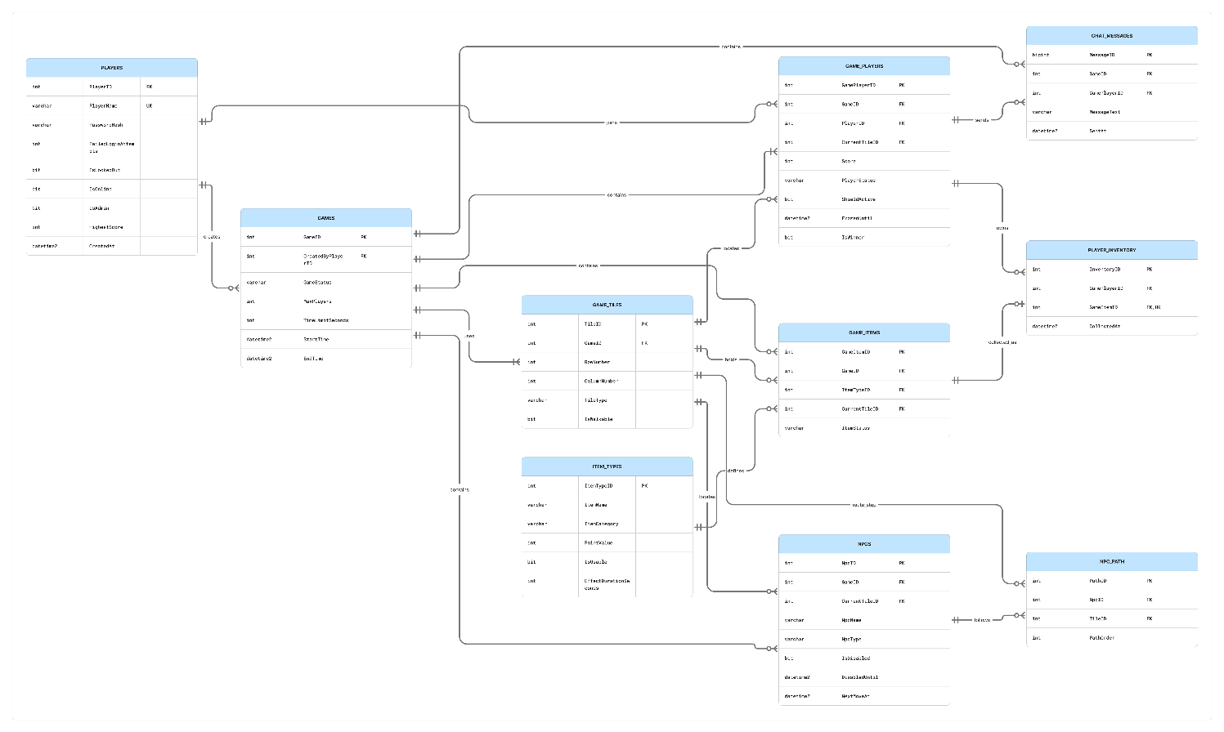
Figure 1: Logical Entity Relationship Diagram for Grid Heist - Blackout Protocol

3.1 Players
Players stores one record per registered account.
- PlayerID (INT) is the primary key.
- PlayerName (VARCHAR(50)) stores a unique username.
- PasswordHash (VARCHAR(255)) stores the password hash, not the plain password. (OWASP Foundation, n.d.)
- FailedLoginAttempts (INT) counts failed logins.
- IsLockedOut (BIT) shows whether the account is locked.
- IsOnline (BIT) shows whether the player is logged in.
- IsAdmin (BIT) marks administrator accounts.
- HighestScore (INT) stores the player’s best score.
- CreatedAt (DATETIME2) stores the registration time.
Five failed logins lock the account. A successful login resets the count and marks the player online. One account can join many games without repeating its account details.

3.2 Games
Games stores the main details of each game.
- GameID (INT) is the primary key.
- CreatedByPlayerID (INT) links to the player who created the game.
- GameStatus (VARCHAR(20)) is Waiting, Active, Completed or Stopped.
- MaxPlayers (INT) sets the player limit.
- TimeLimitSeconds (INT) sets the game length.
- StartTime (DATETIME2) stores when the game starts.
- EndTime (DATETIME2) stores when it ends.
StartTime is NULL while waiting. EndTime is NULL until the game finishes or is stopped. Each game has its own players, tiles, items, NPCs and messages. There is no turn field because players move live.

3.3 GamePlayers
GamePlayers links each player to a game and stores their progress in it.
- GamePlayerID (INT) is the primary key.
- GameID (INT) is a foreign key to Games.
- PlayerID (INT) is a foreign key to Players.
- CurrentTileID (INT) stores the player’s tile.
- Score (INT) stores their score in this game.
- PlayerStatus (VARCHAR(20)) is Playing, Frozen, Left or Finished.
- ShieldActive (BIT) shows whether a shield is active.
- FrozenUntil (DATETIME2) stores when an EMP freeze ends.
- IsWinner (BIT) marks the winner.
GameID and PlayerID are unique together, so each player has only one record per game.
An accepted move updates CurrentTileID. Each player keeps their own position and score.

3.4 GameTiles
GameTiles stores each game’s board.
- TileID (INT) is the primary key.
- GameID (INT) links the tile to its game.
- RowNumber (INT) stores the row.
- ColumnNumber (INT) stores the column.
- TileType (VARCHAR(20)) is Home, Floor, Firewall or Exit.
- IsWalkable (BIT) shows whether players can enter.
GameID, RowNumber and ColumnNumber are unique together. This prevents duplicate board positions.
Each game has its own tiles. Players, items and NPCs must use tiles from the same game.
Movement checks occupancy before accepting a move. Only Home allows players to share a tile.

3.5 ItemTypes
ItemTypes stores details shared by items of the same type.
- ItemTypeID (INT) is the primary key.
- ItemName (VARCHAR(50)) stores names such as Data Chip, Red Fragment, Shield, EMP and Decoy.
- ItemCategory (VARCHAR(20)) is Fragment, Score Item or Tool.
- PointValue (INT) stores the collection points.
- IsUsable (BIT) shows whether the item can be activated.
- EffectDurationSeconds (INT) stores the effect length, where needed.
For example, all EMP items share the name and effect duration stored here.

3.6 GameItems
GameItems stores each individual item in a game.
- GameItemID (INT) is the primary key.
- GameID (INT) identifies the game.
- ItemTypeID (INT) identifies the item type.
- CurrentTileID (INT) stores the item’s tile.
- ItemStatus (VARCHAR(20)) is OnTile, InInventory or Used.
Items of the same type have separate IDs. Ten data chips, for example, have ten GameItemID values and their own locations.
CurrentTileID is NULL for held or used items. If the Glitch moves an item, this field stores its new tile.

3.7 PlayerInventory
PlayerInventory records which player holds each collected item.
- InventoryID (INT) is the primary key.
- GamePlayerID (INT) identifies the player in that game.
- GameItemID (INT) identifies the collected item.
- CollectedAt (DATETIME2) stores the collection time.
GameItemID is unique here, so two players cannot own the same item.
Collecting adds an inventory record and removes the item from the board. Using or dropping it removes the record. Counting held items by type gives the quantities shown on screen.

3.8 NPCs
NPCs stores each game’s Patrol Bot and Glitch.
- NpcID (INT) is the primary key.
- GameID (INT) links the NPC to a game.
- CurrentTileID (INT) stores its tile.
- NpcName (VARCHAR(50)) stores its display name.
- NpcType (VARCHAR(20)) is PatrolBot or Glitch.
- IsDisabled (BIT) shows whether an EMP has disabled it.
- DisabledUntil (DATETIME2) stores when the EMP effect ends.
- NextMoveAt (DATETIME2) stores when it should move next.
Both NPC types need a position and movement time, but they follow different movement rules.

3.9 NPCPath
NPCPath stores the Patrol Bot’s route.
- PathID (INT) is the primary key.
- NpcID (INT) identifies the Patrol Bot.
- TileID (INT) identifies a route tile.
- PathOrder (INT) sets the step order.
The bot follows the steps in PathOrder, then returns to the first step.
NpcID and PathOrder are unique together. The Glitch does not use a fixed route.

3.10 ChatMessages
ChatMessages stores messages sent during a game.
- MessageID (BIGINT) is the primary key.
- GameID (INT) identifies the game.
- GamePlayerID (INT) identifies the sender.
- MessageText (VARCHAR(250)) stores the message.
- SentAt (DATETIME2) stores when it was sent.
Only players in the same game can see its messages. A game and its players can have many messages.

3.11 Relationships Between the Tables
Players and Games have a many-to-many relationship through GamePlayers.
Each Games record can have many GamePlayers, GameTiles, GameItems, NPCs and ChatMessages records.
One ItemTypes record can describe many GameItems records.
One GamePlayers record can link to many PlayerInventory records. Each item has only one owner at a time.
One NPC can have many NPCPath steps.
Primary keys identify records and foreign keys connect tables. (Microsoft, n.d.-a) Unique constraints prevent duplicates.

04. CRUD Analysis
This table shows which records each process creates, reads, updates or deletes.
No. | Process | Tables and attributes involved | CRUD actions and description
1 | Player login, including lockout | Players: PlayerID, PlayerName, PasswordHash, FailedLoginAttempts, IsLockedOut, IsOnline | Read: Find the account using PlayerName. Check PasswordHash, FailedLoginAttempts and IsLockedOut. Locked accounts cannot log in.  Update: A valid login resets FailedLoginAttempts to 0 and sets IsOnline to 1. A wrong password adds 1 failed attempt. The fifth failure sets IsLockedOut to 1.
2 | Player registration | Players: PlayerID, PlayerName, PasswordHash, FailedLoginAttempts, IsLockedOut, IsOnline, IsAdmin, HighestScore, CreatedAt | Read: Check that PlayerName is available.  Create: Save the username and password hash. Use defaults for FailedLoginAttempts, IsLockedOut, IsAdmin and HighestScore. Set IsOnline to 1 and CreatedAt to the registration time.
3 | Laying out tiles on the game board | Games: GameID, GameStatus  GameTiles: TileID, GameID, RowNumber, ColumnNumber, TileType, IsWalkable | Read: Check GameID and GameStatus to confirm a valid game.  Create: Add 64 GameTiles records for the 8 by 8 board, with coordinates, tile types and walkable values. Set Home, Exit and Firewall positions. Keep GameID, RowNumber and ColumnNumber unique together.
4 | Placing an item on a tile | ItemTypes: ItemTypeID, ItemName  GameTiles: TileID, GameID, TileType, IsWalkable  GameItems: GameItemID, GameID, ItemTypeID, CurrentTileID, ItemStatus | Read: Find ItemTypes and check that the selected tile belongs to the game, is a walkable Floor tile and has no item.  Create: Add GameItems with GameID, ItemTypeID and CurrentTileID. Set ItemStatus to OnTile. Do not place items on Home, Exit or Firewall tiles.
5 | Live player movement | Games: GameID, GameStatus  GamePlayers: GamePlayerID, GameID, CurrentTileID, PlayerStatus, FrozenUntil  GameTiles: TileID, GameID, RowNumber, ColumnNumber, TileType, IsWalkable | Read: Check that the game is active and the player is not frozen. Compare tile coordinates for a neighbouring move. Check IsWalkable and other players’ positions; only Home can be shared.  Update: Set CurrentTileID to the accepted TileID. For simultaneous requests to one empty tile, only the first accepted update succeeds. The other player stays in place.
6 | Game scoring | GamePlayers: GamePlayerID, PlayerID, Score, IsWinner  ItemTypes: ItemTypeID, PointValue  Games: GameID, GameStatus, EndTime  Players: PlayerID, HighestScore | Read: Check Score and PointValue. Compare the final score with HighestScore.  Update: Add 10 for a chip, 20 for a fragment and 50 for escaping with all three. Apply penalties without going below zero. Set IsWinner to 1 for the winner, GameStatus to Completed and EndTime to the finish time. Update HighestScore only if improved.
7 | Player acquires inventory | GamePlayers: GamePlayerID, CurrentTileID  GameItems: GameItemID, CurrentTileID, ItemStatus  PlayerInventory: InventoryID, GamePlayerID, GameItemID, CollectedAt | Read: Check that the player and item share CurrentTileID and ItemStatus is OnTile.  Create: Add PlayerInventory with GamePlayerID, GameItemID and CollectedAt.  Update: Set the item’s CurrentTileID to NULL and ItemStatus to InInventory. If it is no longer available, do not collect it.
8 | Move an item or NPC effect | NPCs: NpcID, GameID, CurrentTileID, NpcType, IsDisabled, DisabledUntil, NextMoveAt  NPCPath: NpcID, TileID, PathOrder  GameTiles: TileID, GameID, IsWalkable  GamePlayers: CurrentTileID, Score, PlayerStatus  GameItems: GameItemID, CurrentTileID, ItemStatus  PlayerInventory: InventoryID, GamePlayerID, GameItemID | Read: Check NPC type, position, NextMoveAt, IsDisabled and DisabledUntil. Use NPCPath for the bot’s next step or choose a random legal GameTiles position for the Glitch.  Update: Save the NPC’s CurrentTileID and NextMoveAt. Apply score penalties when it reaches a player. For a Glitch item move, set the item’s CurrentTileID to another empty tile.  Delete/Update: Remove a dropped item’s PlayerInventory record. Set its GameItems.CurrentTileID to the player’s tile and ItemStatus to OnTile.
9 | Administrator stops a running game | Players: PlayerID, IsAdmin  Games: GameID, GameStatus, EndTime  GamePlayers: GameID, PlayerStatus, Score | Read: Check IsAdmin and confirm that the selected game is active.  Update: Set GameStatus to Stopped, record EndTime and set its players’ PlayerStatus to Finished. Keep their scores and reject further moves or item actions.
10 | Administrator adds a new player | Players: PlayerID, PlayerName, PasswordHash, FailedLoginAttempts, IsLockedOut, IsOnline, IsAdmin, HighestScore, CreatedAt | Read: Check IsAdmin and username availability.  Create: Save the username, password hash and account type. Use defaults for FailedLoginAttempts, IsLockedOut, IsOnline and HighestScore. Record CreatedAt.
11 | Administrator updates player information | Players: PlayerID, PlayerName, PasswordHash, FailedLoginAttempts, IsLockedOut, IsAdmin | Read: Check IsAdmin and load the selected PlayerID. Check any new PlayerName against other accounts.  Update: Change PlayerName, PasswordHash or IsAdmin as requested. Unlocking sets IsLockedOut and FailedLoginAttempts to 0.
12 | Administrator deletes a player | Players: PlayerID, IsAdmin  GamePlayers: GamePlayerID, GameID, PlayerID, PlayerStatus  PlayerInventory: InventoryID, GamePlayerID  ChatMessages: MessageID, GamePlayerID  Games: CreatedByPlayerID | Read: Check IsAdmin and the selected player’s GamePlayers records. Stop any active game before deletion.  Delete: Remove related PlayerInventory, ChatMessages and GamePlayers records, then the Players record.  Update: Set CreatedByPlayerID to NULL for games being kept. Complete these changes in one transaction.

Related changes must succeed together. For example, collecting an item must update its location and ownership in the same operation.

05. SQL Implementation
The stored procedure sp_InitializeGridHeistDatabase sets up the ten tables, keys, relationships, checks, indexes and test data.
It removes existing tables before rebuilding them, so running it again resets the test database.
Setup uses a transaction. If a statement fails, the changes roll back rather than leaving a partly created database. (Microsoft, n.d.-b)

5.1 Table Creation Order
Parent tables are created first, starting with Players and Games. Tables that refer to them are created afterwards. Tables are removed in reverse order, with child tables first, to avoid foreign-key conflicts.

5.2 Data Types
INT IDENTITY gives each new record an automatic ID. VARCHAR stores text such as names and statuses. BIT stores yes-or-no values such as IsOnline. INT stores scores, positions and quantities. DATETIME2 stores game times, collection times and effect expiry times.

5.3 Keys and Constraints
Primary keys identify records. Foreign keys connect them, such as GamePlayers.PlayerID linking to Players.PlayerID. Unique constraints prevent repeated usernames and duplicate GameID, RowNumber and ColumnNumber combinations.
Check constraints limit status values and prevent negative scores. An item-location check keeps ItemStatus consistent with CurrentTileID. Items in inventory or already used have no board tile.

5.4 Indexes
Indexes support common searches for online players, active games, positions, board items, NPC movement times and chat messages. They help the database find matching records without checking every row.

5.5 Test Data
Four test accounts cover an administrator, two normal online players and one locked account. They support login, lockout and administration tests. There are two test games: one active and one waiting. Each has an 8 by 8 board with Home, Exit and Firewall tiles.
The active game has two players, data chips, three fragments, a shield, an EMP and a decoy. Nova holds one data chip for inventory testing. It also has a Patrol Bot with a route, a randomly moving Glitch and two chat messages.

5.6 Testing the Procedure
Run the setup procedure with:
EXEC dbo.sp_InitializeGridHeistDatabase;
The procedure returns table counts. Run it twice to check that it rebuilds the test database without duplicate records.
Check the tables, constraints, indexes and test records in SQL Server Management Studio.

06. C# .NET Application Prototype
The prototype uses C# Windows Forms and SQL Server. Its three areas are Login and Registration, Game Play, and Administration.
Windows Forms controls handle user input through events. (Microsoft, n.d.-c) The planned data access objects (DAOs) send requests to SQL Server, where the game rules are checked.

6.1 Application Structure
To strictly enforce the separation of concerns and satisfy the architectural requirements, the application utilizes three distinct Data Access Object (DAO) classes. The UI Forms pass user input to their respective DAOs, which encapsulate the SQL Server connection string and execute the stored procedures:
Display area | Form | DAO class | Purpose
Login and Registration | frmLogin | LoginDAO | Check usernames, register accounts and process logins.
Game Play | frmGame | GameDAO | Load the game and send player actions.
Administration | frmAdmin | AdminDAO | Load players and games, and send administrator requests.

This separates button events from database work.
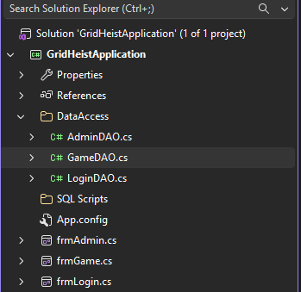
Figure 2: Project structure in Visual Studio.

6.2 Login and Registration Area
The login flow checks a username first. Existing players enter a password; new players are offered registration. Registration asks for the password twice and checks that the username is available.
The form shows login errors and remaining attempts. After five failures, it tells the player to contact an administrator. A successful login opens the lobby. Back returns to username entry.
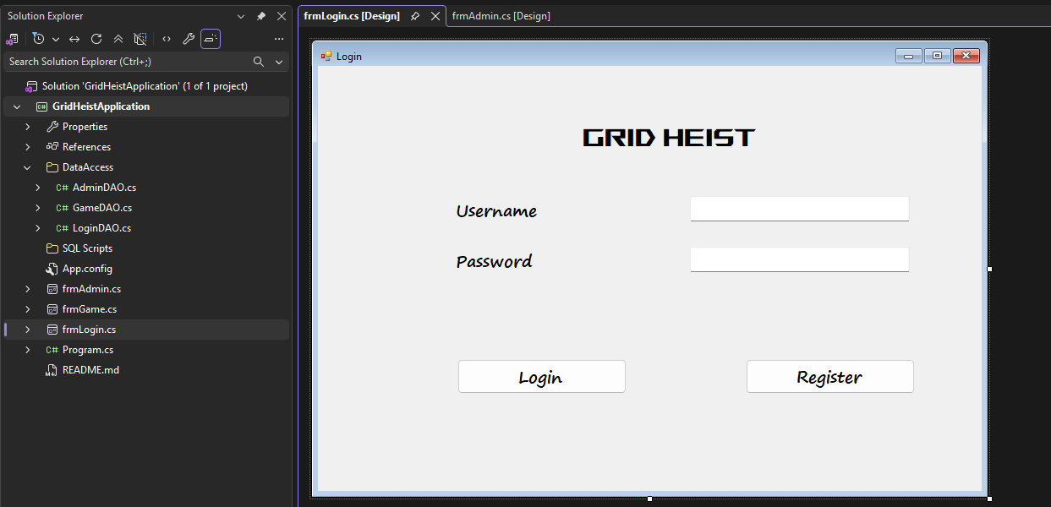
Figure 3: Login form in Visual Studio Designer.
Database connection
LoginDAO will pass the entered values to a stored procedure. Its result will show a message or open the lobby.
- Form event: btnLogin_Click
- DAO method: ValidateLogin(string username, string password)
- Stored procedure: sp_ValidatePlayer
- Parameters: @PlayerName, @PasswordHash (Microsoft, n.d.-d)
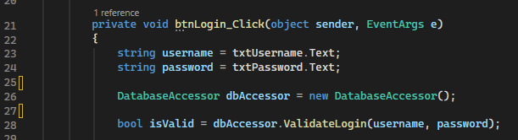

6.3 Game Play Area
The game screen shows the board, player positions, score, inventory, NPCs and remaining time.
Clicking a neighbouring tile sends the player and tile IDs through GameDAO. SQL checks whether the move is allowed.
The returned game state refreshes the screen. There is no turn indicator because players act live.
Players click items to collect them and select tools to use them. The action log shows the results.
Leave Game saves progress and frees the tile without deleting the account.
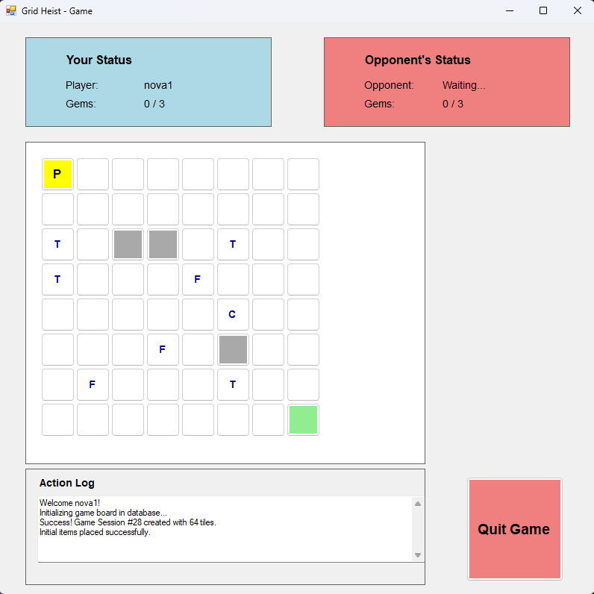
Figure 5: Game play form.

6.4 Administration Area
The administration screen lists players and running games. Selecting a player fills in their details. The administrator can add or update an account, or confirm its removal. To stop a game, select it and confirm Kill Running Game.
Back returns to the lobby. Database requests must check administrator permission; hiding the buttons is not enough.
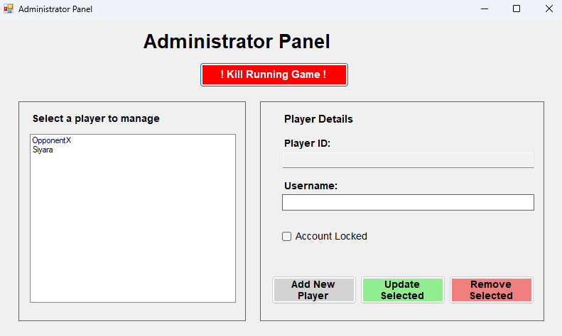
Figure 6: Administration form.

07. Milestone Two: Implementation, Refactoring, and Execution
Building upon the initial design and storyboard architecture from Milestone One, Milestone Two delivers the complete functional implementation of the Grid Heist: Blackout Protocol prototype. Following the core architectural principle that "the database knows best," all game logic, business rules, security constraints, and data validations are fully encapsulated within TSQL stored procedures. The C#.NET Windows Forms application interfaces with SQL Server exclusively through dedicated Data Access Object (DAO) classes, ensuring a clean separation of concerns. All 12 core CRUD processes are fully operational and tested.

7.1 User Authentication and Account Management

7.1.1 Player Login and Account Lockout
The authentication workflow relies on the sp_ValidatePlayer stored procedure executed exclusively via LoginDAO. When a user submits credentials through frmLogin, the database evaluates the username against the stored PasswordHash. If the login is successful, LoginDAO.GetUserAdminStatus() is immediately called to evaluate the IsAdmin flag. Standard players are securely routed to frmGame, while administrators are routed to frmAdmin. To mitigate brute-force risks, the system tracks FailedLoginAttempts and evaluates the IsLockedOut bit flag.
- Failure Handling: Invalid passwords increment the failure count by 1. Upon reaching 5 consecutive failures, IsLockedOut automatically transitions to 1, locking the account and requiring administrative intervention.
- Success Handling: Valid credentials reset FailedLoginAttempts to 0, set IsOnline to 1, and return a success token that launches the appropriate dashboard.
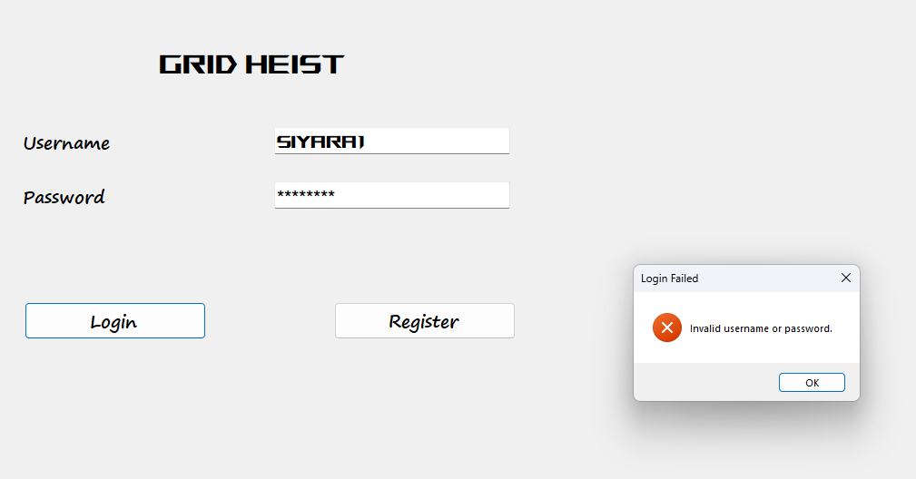
Figure 7-Login interface capturing user credentials
- Success Handling: Valid credentials reset FailedLoginAttempts to 0, set IsOnline to 1, and return a success token that launches the game lobby.
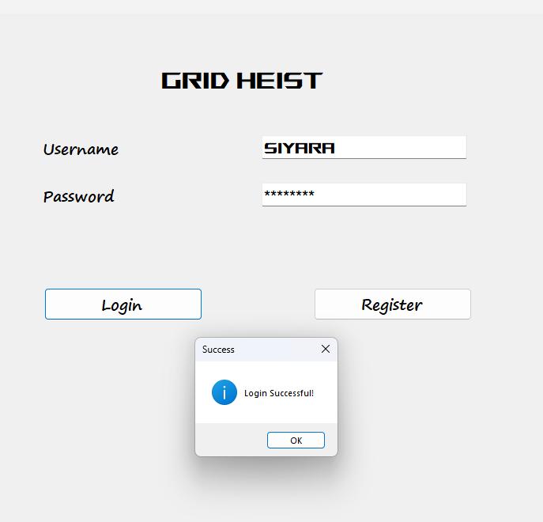
Figure 8- Success Login responcce

7.1.2 Player Registration & Session Initialization
Unrecognized usernames prompt the automated registration workflow. The registration form captures credentials, verifies password confirmation matching, and queries the database for username availability. Upon validation, the database generates a secure password hash, applies default parameters (FailedLoginAttempts = 0, IsLockedOut = 0, IsAdmin = 0, HighestScore = 0), sets IsOnline = 1, records the CreatedAt timestamp, and initializes the player record. Successful registration acts as an immediate session sign-in.

7.1.3 Account Deletion & Security Confirmation
Player-initiated account deletion requires re-entering the account password as a security measure against unattended terminal access. The backend procedure verifies that the player is not currently active in an ongoing game session. Once verified, it executes a clean transactional deletion, wiping associated records in PlayerInventory and GamePlayers before removing the tuple from the Players table and returning the user to the startup interface.

7.2 Game Play Core Mechanics

7.2.1 Board Generation and Tile Layout
Game sessions initialize on an isolated 8x8 grid managed by the GameTiles table. When a match is created, the database generates 64 distinct tile records linked by GameID, assigning explicit RowNumber, ColumnNumber, TileType (Home, Floor, Firewall, Exit), and IsWalkable properties. Unique composite indexes on GameID, RowNumber, and ColumnNumber prevent coordinate collisions. Firewall tiles restrict entry (IsWalkable = 0), while Home tiles permit shared player occupancy.

7.2.2 Live Player Movement Validation
Live movement is governed by the sp_MovePlayer stored procedure. When a player clicks a neighboring tile on frmGame, the C# layer passes coordinates to the database, which performs multi-stage validation:
- Adjacency Check: Confirms that movement is restricted to exactly one step orthogonal (Up, Down, Left, Right) using coordinate absolute differences ($|CurrentRow-TargetRow|+|CurrentCol-TargetCol|=1$), prohibiting diagonal jumps.
- Walkability Check: Enforces IsWalkable = 1, blocking attempts to traverse Firewall tiles.
- Occupancy Check: Ensures non-Home target tiles are free of other players (GamePlayers.CurrentTileID).

7.2.3 Item Placement and Inventory Acquisition
Items (T, F, C) spawn on valid floor tiles via GameItems. Stepping onto a tile containing an active item (ItemStatus = 'OnTile') triggers an atomic database update: the item status changes to 'InInventory', its board coordinate is set to NULL, and a new record is inserted into PlayerInventory linking GamePlayerID, GameItemID, and CollectedAt. The procedure returns MoveStatus = 2, instructing the C# client to clear the item from the grid view.

7.2.4 Scoring and Real-Time Dashboard Updates
Score calculations are maintained within the GamePlayers table (Score = Score + 10 per acquired item). frmGame polls DatabaseAccessor.GetPlayerScore() immediately following every successful move, synchronizing the UI status labels (lblYourGemsValue) in real-time.
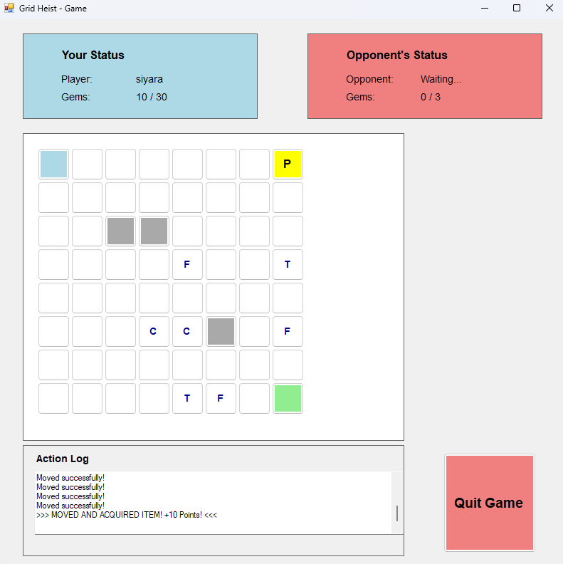
Figure 9: Active Game Play form showing player position (P), item placement, action log, and synchronized score counters (10 / 30)

7.2.5 NPC and Item "Data Glitch" Behavior
To fulfill autonomous world dynamics , a background System.Windows.Forms.Timer operates inside frmGame on a 3-second interval. Each tick executes DatabaseAccessor.MoveNPC(), calling the sp_MoveNPC stored procedure. The procedure randomly selects an uncollected item on the board and shifts its CurrentTileID to an adjacent walkable floor tile, creating a dynamic moving-target mechanic for players.

7.2.6 Win Condition and Victory State Management
The game's primary win condition is enforced at the database level when a player attempts to step onto an Exit tile. As defined in the sp_MovePlayer procedure, the database verifies if the player has collected the required fragments (simulated by checking PlayerInventory counts).
- Access Denied: If the player lacks the required fragments, the database returns a -2 status, blocking the move and generating an "Access Denied" log in frmGame.
- Victory Execution: If the condition is met, the procedure updates the GamePlayers table by adding a 50-point escape bonus, setting IsWinner = 1, and changing PlayerStatus to 'Finished'. It simultaneously updates the HighestScore in the Players table if the new score surpasses their previous best, and sets the Games table GameStatus to 'Completed'.
- UI Synchronization: GameDAO captures the success status (3) and immediately triggers ShowVictoryScreen(), halting the npcTimer and displaying a final results summary fetched via GameDAO.GetGameResults() before safely routing the user back to the lobby.

7.3 Game Administration and System Control

7.3.1 Administrator Dashboard Overview
The administration panel (frmAdmin) provides an interface restricted to accounts with IsAdmin = 1 privileges. All administrative actions are managed exclusively via the AdminDAO class, completely isolating management queries from standard gameplay. The interface communicates directly with backend management procedures (sp_AdminGetAllPlayers, sp_AdminAddPlayer, etc.) to supervise player accounts and active game instances with strict database-level authorization checks.

7.3.2 Adding and Updating Player Accounts
Administrators can provision new accounts with temporary credentials (e.g., Temp#123) or modify existing user attributes (such as usernames and account lock states) directly from the console.
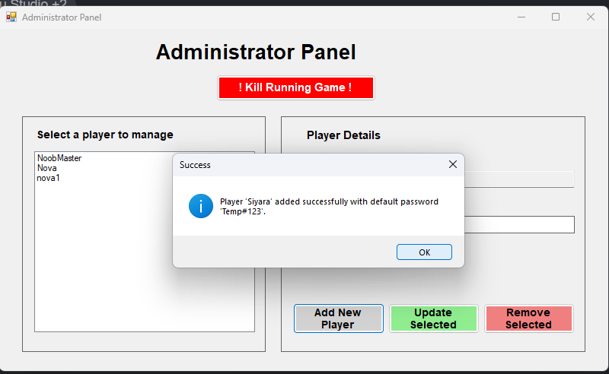
Figure 10: Administration panel showing successful player addition (Siyara)
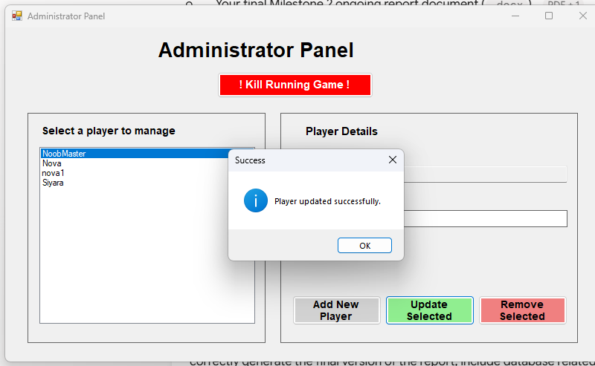
Figure 11: Administration panel showing player update success

7.3.3 Removing Players and Terminating Active Games
Administrative maintenance includes secure deletion workflows and session termination commands (Kill Running Game).
- Deletion Workflow: Prompts administrators with a warning dialog before purging associated records in PlayerInventory, ChatMessages, and GamePlayers, followed by the player tuple.
- Game Termination: Sets GameStatus = 'Stopped', records EndTime, transitions player statuses to Finished, and safely returns users to the lobby.

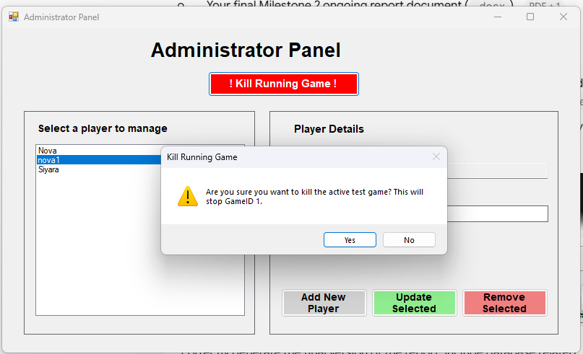
Figure 12: Confirmation dialog for permanent player removal

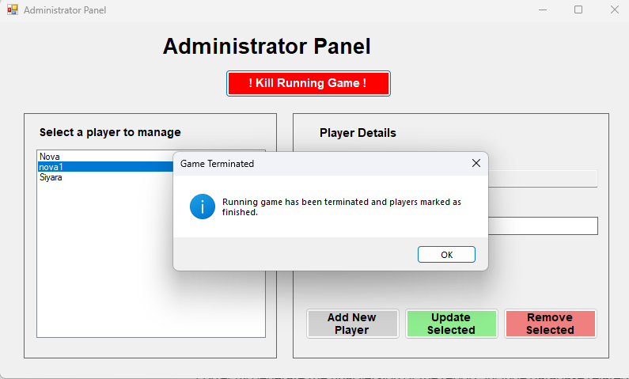
Figure 13: Confirmation dialog for terminating active game session)

7.4 Version Control and Repository Management
Throughout the development and implementation of Milestone Two, all iterative refactorings, C# Windows Forms application source files, and backend database scripts were systematically tracked and committed to version control. To ensure complete system reproducibility and transparency, the official GitHub repository contains both the complete C# solution and all foundational TSQL database creation scripts, table constraints, indexes, and stored procedures (sp_ValidatePlayer, sp_MovePlayer, sp_MoveNPC, and administrative management procedures).
The complete, version-controlled project repository is publicly accessible at:
https://github.com/Siyara11/GridHeistApplication.git

08. Conclusion
Grid Heist: Blackout Protocol is a live multiplayer game focused on collecting three code fragments and reaching the Exit portal. Features such as interactive tactical tools, the Patrol Bot, and the dynamic Glitch require players to continuously adapt their strategies during live gameplay. This report comprehensively covers the game rules, relational database design, CRUD analysis, SQL schema setup, and the implementation of the three core C#.NET application areas.
Milestone Two of Grid Heist: Blackout Protocol successfully transitions the initial architectural design into a robust, fully integrated multi-user database application. By strictly adhering to the "database knows best" design paradigm, all 12 core CRUD processes encompassing secure authentication, account lockouts, live 8x8 grid movement validation, inventory management, scoring synchronization, autonomous NPC/glitch behaviors, and administrative lifecycle controls have been thoroughly implemented via TSQL stored procedures and C# data access objects.

09. References
OWASP Foundation, “Password Storage Cheat Sheet,” OWASP Cheat Sheet Series. [Online]. Available: https://cheatsheetseries.owasp.org/cheatsheets/Password_Storage_Cheat_Sheet.html. [Accessed: 2 September 2026
Microsoft, “Primary and foreign key constraints,” Microsoft Learn. [Online]. Available: https://learn.microsoft.com/en-us/sql/relational-databases/tables/primary-and-foreign-key-constraints?view=sql-server-ver17. [Accessed: 3 September 2026]
Microsoft, “Transaction locking and row versioning guide,” Microsoft Learn. [Online]. Available: https://learn.microsoft.com/en-us/sql/relational-databases/sql-server-transaction-locking-and-row-versioning-guide?view=sql-server-ver17. [Accessed: 3 September 2026].
Microsoft, “Windows Forms Overview,” Microsoft Learn. [Online]. Available: https://learn.microsoft.com/en-us/dotnet/desktop/winforms/overview/. [Accessed: 1 September 2026].
Microsoft, “Configuring parameters and parameter data types,” Microsoft Learn. [Online]. Available: https://learn.microsoft.com/en-us/dotnet/framework/data/adonet/configuring-parameters-and-parameter-data-types. [Accessed: 2 September 2026]

